# Section 1: Project Plan

## Project Title

Comparative Analysis of Cricket Shot Classification Using Deep Learning: PyTorch vs. TensorFlow

## Research Question

What is the comparative performance of Pytorch and TensorFlow in terms of training time, accuracy, precision, and F1 score when classifying different cricket shots from image data?

## Objectives

* To clean and preprocess the cricket shots dataset for training a DL model.
* To implement model a deep learning model development using two frameworks PyTorch and TensorFlow.
* To compare these models based on multiple metrics like speed, accuracy, precision and f1 score.
* To evaluate the performance of this system on real life data.

## Background and Summary

Cricket is a sport that is famous worldwide with multiple countries participating in it every year. There are multiple variations of shots that a player can play in each turn. By using the power of deep learning and computer vision (*Computer vision in sports: applications and challenges*, no date), a deep learning system can be trained to classify the kind of shot a player played. This research explores the dataset curated on the open-source website Kaggle. This dataset will be augmented (Sharma, 2021) to increase the number of records. To conduct this research two frameworks PyTorch (Simplilearn, 2021) and TensorFlow (Banoula, 2020) will be used and to construct and train the models.

Although there are advanced computer science techniques being used in cricket right now, the power of ML and AI are not yet fully being utilized. A main challenge is that each player has his own unique posture and style of playing a certain shot. Existing methods for this classification is manual where a person manually looks at the shot and labels it based on the domain knowledge. This process can be automated using a well-built machine learning system, to not only save time but to increase the use of AI in this sport. This research project mainly aims to advance the use of AI and machine learning in the field of sports especially cricket. By comparing two different frameworks, more insights can be gained. Though this project only focuses on trying to predict the types of cricket shots from images, in further research it has the potential to do this using a video input or even live streaming. The hardware and software requirements may be increased but there is high scope of research in this area.

## List of References

Bhat, I. et al. (2023) “Building a video dataset for cricket shot analysis,” in 2023 International Conference on Network, Multimedia and Information Technology (NMITCON). IEEE, pp. 1–6.

<https://ieeexplore.ieee.org/document/10276358>

Fernandes, J. B. et al. (2023) “Cricket shot detection using 2D CNN,” in 2023 7th International Conference on Intelligent Computing and Control Systems (ICICCS). IEEE, pp. 608–612.

<https://ieeexplore.ieee.org/document/10142272>

Jagadeesh, M., Rithesh and Sagar (2023) “Cricket shot detection using deep learning: A comprehensive survey,” in 2023 International Conference on Networking and Communications (ICNWC). IEEE, pp. 1–8.

<https://ieeexplore.ieee.org/document/10127412>

Mannan, M. et al. (2021) “Detection of cricketing activities using deep learning,” in TENCON 2021 - 2021 IEEE Region 10 Conference (TENCON). IEEE, pp. 1–6.

<https://ieeexplore.ieee.org/document/9707392>

# Section 2: Task List and Project Time Line

The Project is divided into 7 major subsections each of which will be followed by the next. The first part of any research is to Collect the data and create a project plan that encompasses the flow and pace at which the research will be conducted. For each subsection 2 weeks of time is allotted, this is subject to change as the research progresses. If in any case one of the modules completes faster, the remaining time can be utilized to check the already completed sections and prepare for the next sections.

* TensorFlow: This framework is the most used framework to develop and train neural networks. This is a core module in this research along with the next module.
* Pytorch: This is another framework for developing neural networks that is famous for its ease of usage.

Both these main modules lay as the core to this research project. Comparison of these two modules will inherently result in development of a deep-learning based classification engine for cricket.

The next subsection/module in this project is the development of an application. This is not intended to be used as a large-scale deployment application rather for the easy use of testing of the two frameworks and saving the results. Instead of manually logging the results, this application could easily test and log the results in a suitable file format for further analysis.

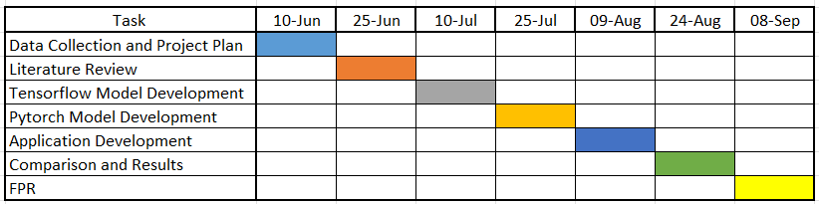

# Section 3: Data Management Plan

## Summary of Dataset

The dataset contains four classes each of which represent a type of shot in Cricket. Each shot is a class in this dataset, for each class there are almost 1100 to 1200 images present as shown in the picture below. Together the total dataset has around 4400 to 4600 images. Most of the images are in “.png” file format which is an image file format. All the images have 3 channels – Red, Green and Blue. The images consist of a diverse range of players practicing in nets to playing in the world cups, there are players of multiple nations with varying jerseys.

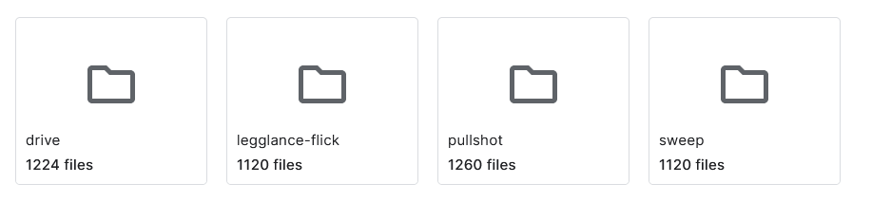

Ex images:

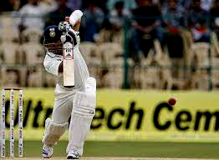 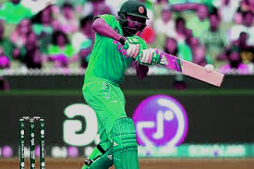

## Data collection

Data is collected through online open-source website called Kaggle, where the data is free to use and does not require any ethical approvals.

## Document control

To keep a track of the changes and save the progress periodically a version control system will be used. This research report is going to use Git as the version control system and GitHub to host the repository.

GitHub Repository Link –

https://github.com/Itsmyaccount12/Machindra_Final_Project_Cricket.git

## Ethical requirements

* Does the data meet GDPR requirements? – Yes
* Does the project conform to UH ethical policies? – Yes
* Do you have permission to use the data for your proposed research project? – Yes
* Are you assured that the data was collected ethical (i.e. by the original people who gathered/collected/ collated/made the data)? – Yes

# References

Banoula, M. (2020) *What is TensorFlow? Deep learning libraries and program elements explained*, *Simplilearn.com*. Simplilearn. Available at: https://www.simplilearn.com/tutorials/deep-learning-tutorial/what-is-tensorflow (Accessed: June 8, 2024).

*Computer vision in sports: applications and challenges* (no date) *Superannotate.com*. Available at: https://www.superannotate.com/blog/computer-vision-in-sports (Accessed: June 8, 2024).

Sharma, G. (2021) *Image classification with tensorflow: Data augmentation on streaming data (part 2)*, *Analytics Vidhya*. Available at: https://www.analyticsvidhya.com/blog/2021/05/image-classification-with-tensorflow-data-augmentation-on-streaming-data-part-2/ (Accessed: June 8, 2024).

Simplilearn (2021) *What is PyTorch, and how does it work: All you need to know*, *Simplilearn.com*. Simplilearn. Available at: https://www.simplilearn.com/what-is-pytorch-article (Accessed: June 8, 2024).